Guidelines for time registration forms for employees
You belong to the group of employees who must register their daily working hours, and from 2025 this form must be updated in SharePoint.

You log on to SharePoint by going to office.com and logging in with your AU ID and password. Select SharePoint and then you will be able to see an overview of the SharePoint sites you have access to. | https://aarhusuniversitet.sharepoint.com/sites/AGROarbejdstidsregistreringworkhours/Delte%20dokumenter/  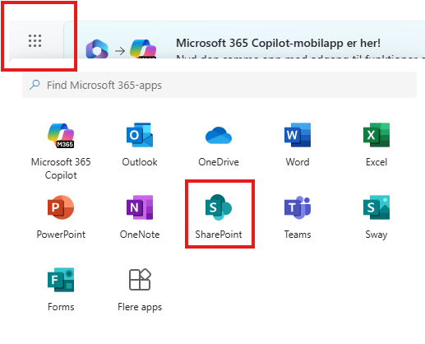
On SharePoint, a group has been created called AGRO arbejdstidsregistre/work hours. | 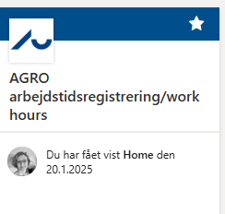
Under Documents is a folder for each section.  Here you will find your schedule for the given year under your section. | 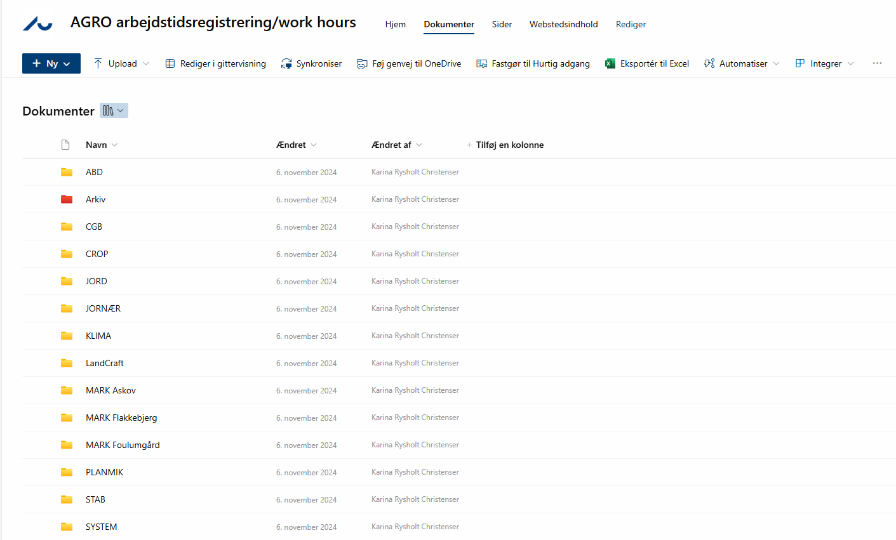
On the basic information tab, you can fill in your normal working hours, and you can also fill in the projects you are working on.  For people in MARK and LAB, the use of assignment/  project sheet  is agreed with TAP coordinator/  Section Manager | 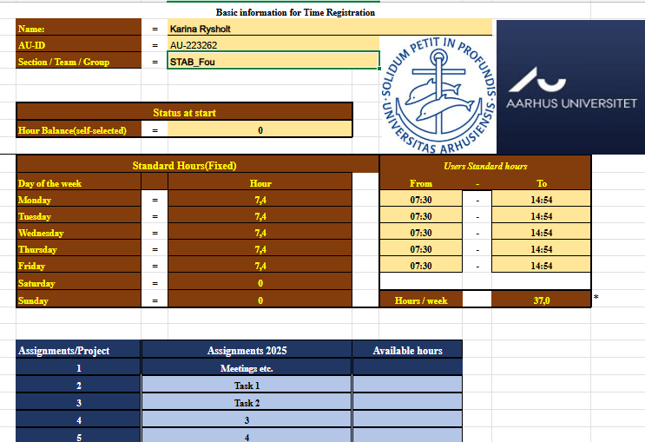
On the month tap you fill in when you come and when you go each day.  For a full day of absence, delete the time and write “yes” in absence  For a part time day off, register the hours worked, and press “yes” in absence.  If you want to use flex/hour balance, you write the hours you have been working or delete the times for a full day.  If you have more meetings time on one day, you can indicate it in the comments field.  When you have finished the registration, write a date in the bottom, as confirmation that everything is registered corectly | 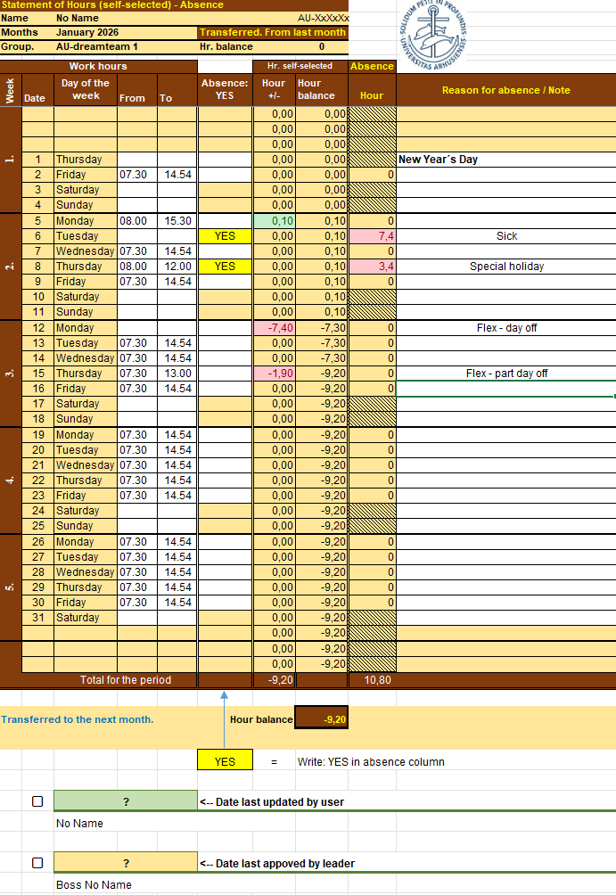

The following people have access to your schedule: yourself, your section manager, your section coordinator, Chinette Møller, Karina Rysholt and Ida Thoft.
You must update your spreadsheet with working hours for the previous month no later than the 5th of each month.
It is the form on SharePoint that is the applicable form, so you are obliged to update this form according to the guidelines. Other forms will not be approved. At the end of the year, the sheet will be moved to the archive, and you will receive a new schedule for the new year.
If you are part of a project that registers project time, you should be aware that project time registration does not replace working time registration. Therefore, in addition to your daily registration of working hours in the sheet in SharePoint, you must also register your given project time in mitHR.
It is your responsibility to ensure that all absences are registered correctly in mitHR.
The section/field manager will check your working hours every month before the 10th to ensure that no more work is done than the hours specified by law.
Backup will be taken from SharePoint every month to ensure documentation of previous months' registrations.
It is not possible to have multiple arrival and departure times in the spreadsheet. If you have had multiple arrival and departure times on a single day, please note this in the comments field.
If you change your working hours during the year, please contact your section coordinator, who will ensure that you receive a new time registration sheet.
Any conversion to saved days, cf. Circular on the state working hours agreement §11, will be assessed in December and implemented in April. Approval from your immediate manager should be sent to hrbreve@agro.au.dk, who will then obtain approval from the head of department.
Conversion of accumulated leave, cf. the agreement, is done by contacting hrbreve@agro.au.dk. Information must be sent about which days of overtime are to be converted, as well as documentation from the immediate manager that the overtime on the specified days has been approved.

