Guidance for section managers/field managers about time registration forms
As a manager, you are responsible for ensuring that the framework and rules for time registration are complied with in your section.
As a manager, you are responsible for ensuring that your employees are familiar with the guidelines for working time registration at Aarhus University.
Regardless of whether the employee is obliged to register working hours or is exempt from the requirement, it is your responsibility to follow up on the employees' working hours and ensure an appropriate balance between tasks and working hours.
For your employees who are subject to the registration obligation, you have access to their working hours schedule in Sharepoint.
Every month before the 10th, you must check your employees' working hours. Pay special attention to employees who are approaching the maximum weekly working hours of 48 hours over a 4-month period.
You log on to Sharepoint by going to office.com and logging in with your AU ID and password. Select SharePoint and then you will be able to see an overview of the SharePoint sites you have access to. | 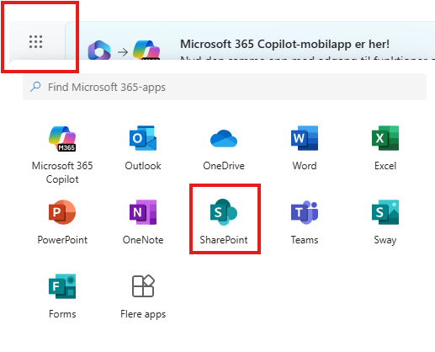
On sharepoint, a group has been created called AGRO arbejdstidsregistre/work hours. | 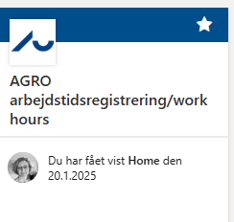
Under Documents is a folder for each section.  You can only see schedules in your own section. | 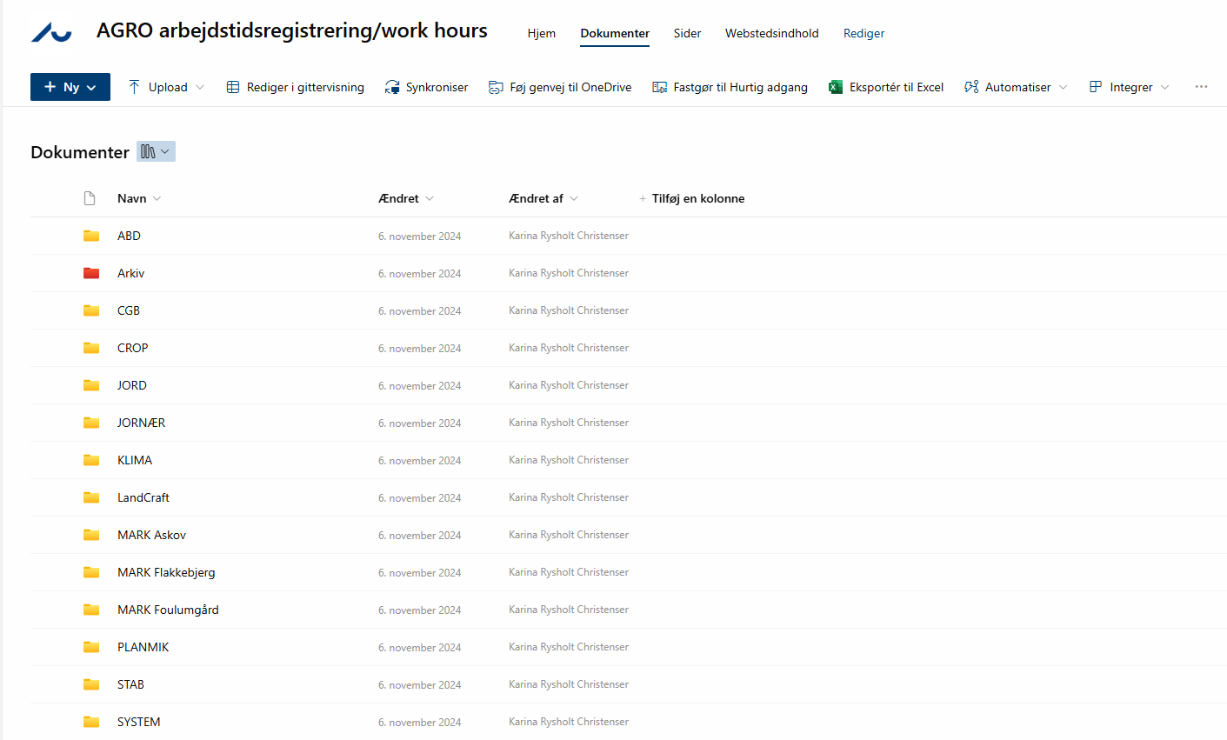

Each month, you must indicate on the spreadsheet that you have checked and approved the month's records. This is done by entering a date in the field at the bottom of the given month.
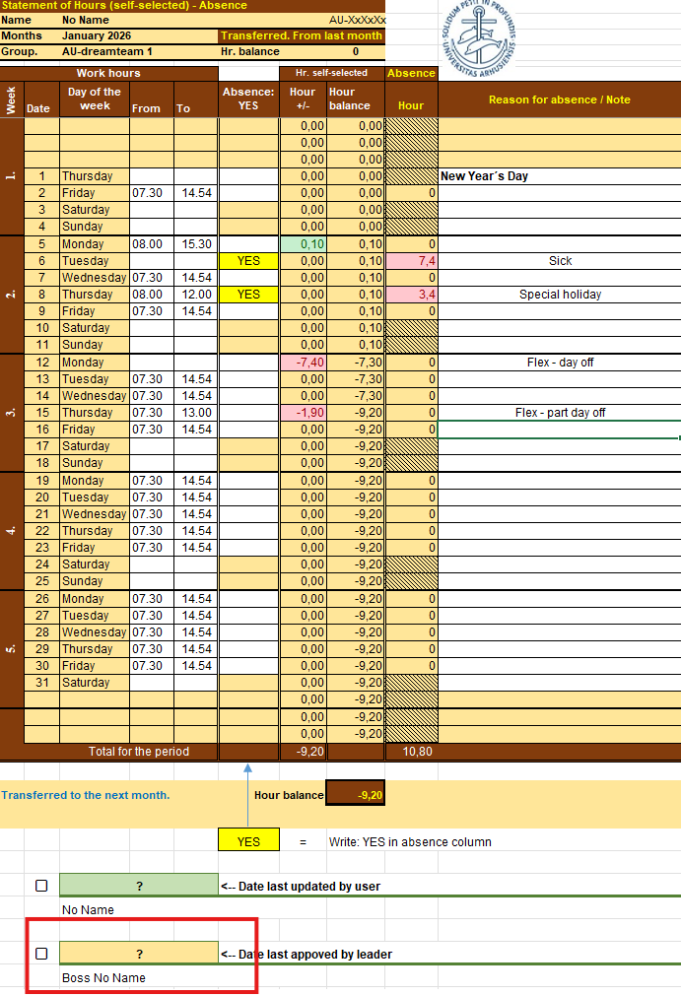

If you have employees who work overtime, you must approve this overtime every month before the 10th. You do this by downloading the employee's form and putting it in the folder on O:
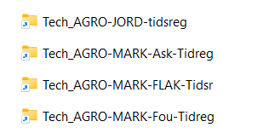
The form must be named with the month in which the overtime was made and approved for:
2025_medarbejder navn_måned (ex: 2025_Karina Rysholt_januar)

