AGRO GUIDELINE FOR TENURE TRACK PROGRAMME FROM APPOINTMENT TO FINAL EVALUATION

- APPOINTMENT
1.1. The head of department sends an email to inform the candidate that the dean has “approved the recommendation of the candidate for the position”.
1.2. TECH HR sends a certificate of employment to the new employee after agreement on the salary.
1.3. TECH HR sends an email to the Head of Department informing that a meeting is to be scheduled with the tenure track, where the person is made aware of the requirements, guidelines and expectations associated with the tenure track process.

2. DEVELOPMENT PLAN
2.1. The tenure track, the head of department and the section leader will within the first month of employment fill out the Development Plan and the form showing initial status of the tenure track with respect to ABC criteria. After signature Agro HR files the plan under the TECH HR created file, so the TECH vice dean, TECH HR, and institute can follow the employee's development, example :2024-xxxxx, Udviklingsplan, Tenure Track Adjunkt, xxxxx xxxxx, AU00000

Please find the template for the development plan here https://agro.medarbejdere.au.dk/fileadmin/DJF/Agro/Medarbejderportal_AGRO/Personale/Procedurer/Development_plan_Tenure_Track_feb_2024_eng_EMPTY.docx
The template for the status with respect to ABC criteria can be found here
https://agro.medarbejdere.au.dk/fileadmin/DJF/Agro/Medarbejderportal_AGRO/Personale/Procedurer/AGRO_Annual_update_Tenure_Track_Programme_marts_2025__1_.docx

3. ANNUAL UPDATES
During the up to 6 years of the tenure track process, there will be annual follow-ups discussions with the head of department and a designated senior scientific employee in the department. The head of department delegates this to the respective section leader, except for year 2 and year 3.
3.1. The purpose of the annual follow-up is to:
- ensure that the tenure track assistant professor/researcher is on the right track in relation to achieving a positive final evaluation.
- advise the tenure track assistant professor/researcher how to plan the remaining time of the tenure track programme.
3.2. The forms to be filled out at the follow-up meeting will show how far the tenure track assistant professor is from associate professor level for the various criteria. The forms are available at
https://agro.medarbejdere.au.dk/fileadmin/DJF/Agro/Medarbejderportal_AGRO/Personale/Procedurer/AGRO_Annual_update_Tenure_Track_Programme_marts_2025__1_.docx
3.3. It is of high importance that the annual follow is taking place every year at the same time (date of appointment), so that a halfway evaluation will be at the exact three years of employment. If the fast-track model is decided at the year 2 follow-up, the yearly follow-up will continue, se description 4.
The “development plan” is an element of the overall basis for the interim evaluation together with the ABC criteria.

4. ANNUAL UPDATE, SECOND YEAR (follow-up with choice of process)
4.1. After two years of employment, the head of department assesses how far the tenure track assistant professor is from associate professor/senior researcher level, and whether there is still to be two-four years of employment before a final assessment is initiated, or whether an assessment should be initiated within the next two years of employment
Normal process: If it is expected that there will be between two and four years of employment, an interim evaluation will be conducted after three years of employment.
Accelerated process: If the updated plan clearly shows that the employee will be at associate professor/senior researcher level within two years of employment, no interim evaluation will be made. Instead, the annual follow-ups will continue until the final evaluation two years later.

5. THIRD YEAR (if interim evaluation)
5.1. The interim evaluation is usually conducted after three years of employment.
The purpose of the interim evaluation is:
- To ensure that the tenure track assistant professor is on the right track with regard to achieving a positive final evaluation.
• To advise the tenure track assistant professor regarding planning the remaining time of the tenure track programme.
• To give feedback to the tenure track assistant professor from internal and external assessors.
• To support the qualification of the basis for the final assessment.

5.2. If the Tenure Track requests to have the final evaluation after three years the process will be conducted; however, there will be a risk of been evaluated not qualified, and then the assessment will take place within the last six months of the employment

6. FINAL EVALUATION
At the end of the tenure track programme (after 4 or 6 years), a final evaluation is initiated with a view to assessing whether the tenure track assistant professor meets Tech’s criteria for permanent employment. The final evaluation takes place within the last six months of the appointment as tenure track assistant professor and must be completed before the end of the programme (no later than six years after the appointment), unless an accelerated process (four years) has been decided.
The development plan with annual update and possible interim evaluation are elements of the overall basis for the final assessment.
In accordance with the tenure track process, the candidate is entitled to demand that the final evaluation be initiated at any time within the first four years. As earlier mentioned, the candidate must be aware that the development plan with the annual updates and the interim evaluation is included in the assessment basis, and if the assessment is “not qualified”, then there is only one opportunity left for assessment, and it must take place within the last six months of the employment. It is therefore recommended that the candidate and the head of department have a thorough dialogue about options before requesting final evaluation.

THE HEAD OF SECTION ARE RESPONSIBLE FOR SENDING THE FOLLOWING INFORMATION TO AGRO HR hrbreve@agro.au.dk
- Who will be supervisor and attend the annual follow up meetings together with the head of section
- Make sure that the first annual follow-up meeting is scheduled within 13 months from start date (Agro HR sends a reminder to the head of section)
- Make sure that the tenure track keeps their CV updated in reference to the annual follow-ups

HR AGRO ARE RESPONSIBLE FOR:
- Inviting the head of department, section leader and the tenure track for the meeting within the first month of employment (to fill out the development plan)
- Reminding the head of section to schedule the annual follow-up at year one, and include the relevant documents
- Scheduling the annual follow-up year two with the tenure track, head of department, head of section and the supervisor
- Informing TECH HR before year three whether there will be a fast track or halfway evaluation
- After the halfway evaluation and/or fast track decision send a reminder for the yearly follow-up meetings (year four and five)

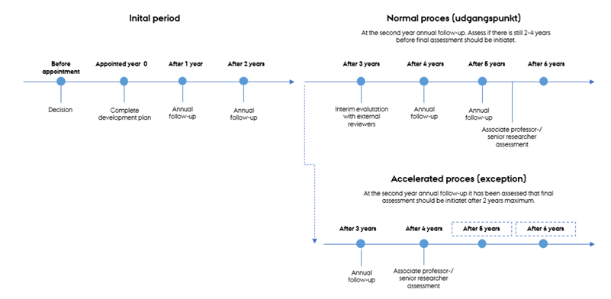

Please find more information regarding the Tenure Track programme here
https://tech.au.dk/fileadmin/tech.au.dk/HR/Vejledninger_Tech_ENG/Tenure_track_-_vejledning__eng__Oct_23.pdf
Please find the ABC Criteria here:
https://tech.au.dk/fileadmin/tech.au.dk/HR/Vejledninger_Tech_DK/Kriterier_for_varig_ansaettelse__Tech_.pdf

